**Proposed Methodology**

The whole system is designed and coded in Visual Studio. System uses Text to Speech API and formulation of Speech to Text API. We convert Speech to Text to Speech to Sign for images and videos. System is fully functional in Text to Speech and Speech to Sign format. Some other function is also included in this project like Learning System, Text to Sign and Quiz Competition.

**Flow Chart:**

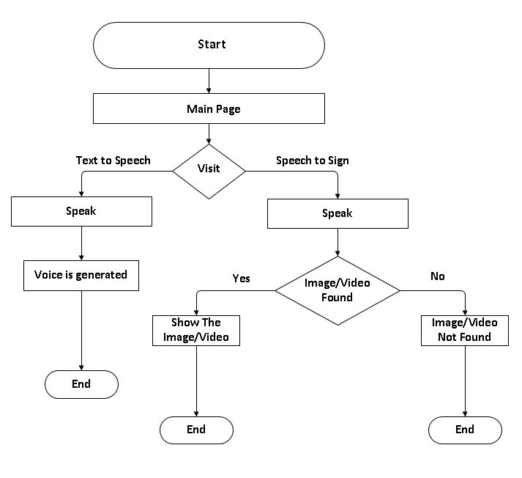

**Figure 5.1 Flow Chart**

The above flow chart explains the the functionality of the website. Following points will be showing how this flow chart works

1. **Main Page:** User need to move to the main page for every step to proceed. From the Main page the user can either move to the Speech to Sign page ot to the Text to Speech page.
2. **Speech to Sign page:** In this page user will be given an interface in which user can speak the words or the sentences to get the desired image or the video to watch. There are two possibilities at this page after the user speaks. Either the sign will be shown or the the sign will not apear. For the sign not displayed means that the sign is not available at the database of the application. At this point user can visit the learning page and upload the relevent sign or try to fetch for other sign by repeating the steps of Speech to Sign again.
3. **Text to Speech:** At Text to Speech page user can use the button given at the bottom of the text area at the page to record for the sentence or the word which will be processed to generate in the from of voice.

There are also some other functionalities of the application like the Learning System and the Quiz Cpmpetition in which user can learn and evaluate him self by visiting those pages. Informational pages are also a part of this application in whhic user can know or learn about different types of impaired people.

**Application Programmig Interfaces:**

This system basically include two APIs. One is Text to Speech which is eaisly Avaliable on internet but the secound API is quite hard to find because it is modified vesrion of Speech to Text API beacause we have modified the Speech to Text API into Speech to Sign. As per need of our System, we have modified Speech to Text API to Speech to Sign.

**Functionality of the APIs:**

* **Text to Speech:**

**Step1:** Start

**Step2:** Move to Text to Speech API page.

**Step3:** Click on the icon below the text area at the page.

**Step4:** Keep pressing the button and speak something.

**Step5:** Release the button and wait sometime for processing.

**Step6:** Text of the given speech will be shown to the screen in text area field while the voice will also be generated along the text.

**Step7:** Stop

* **Speech to Sign:**

**Step1:** Start

**Step2:** Move to Speech to Sign page.

**Step3:** There will be two button below the text area. One for recording the sound for image and the second for showing the relevent image.

**Step4:** Press the Mic/recording button and wait the system to process.

**Step5:** Keep pressing the button and speak something and wait for the system to process.

**Step6:** Text of the spoken speech will be shown into the text area.

**Step7:** Then press the show image button to watch the relevent image or the video.

**Step8:** System will process the text and find the relevent video from the database.

**Step9:** Stop

**Other Functionalities:**

Other functionalities includes

1. **Learning System**
2. **Quiz Competition**
3. **Admin Portal**
4. **User Portal**

**Learning System:** This functionality includes the learning phase in which user can learn the American Sign Language by watching different signs and bu uploading different signs in order to help other by increasing the database of the the application. This phase also includes the search for signs by typing the name of the sign and get the desired sign.

**Quiz Cometition:** This phase includes the evaluation of the knowledge of the user. User can participate in the quiz by log in with the registered email and password and participate in the quiz. User will be given 1 minute and 10 picture to which 4 answer will be given. User have to select one answer to one picture. When the user attemp all answer the result will be shown to the user. In this way he can evaluate himself.

**Admin portal:** This page includes the admin panel in which admin can look all the database activities done by the users. It can either be the registration of the user, log in of the user or the uploading of the user.

**User Portal:** This phase includes the user activities like registration and login. User need to log in in order to use the Learning page or the Quiz page.

**Software Model:**

System includes iterative modeling technique which is a particular implementation of SDLC (Software Development Life Cycle) that focus on step by step implemetation work. After intial planning phase, a small helpful of stage were repeated over time to time with the compiltion of each cycle a part of the system was designed. Through incremental approch, our system has been designed.

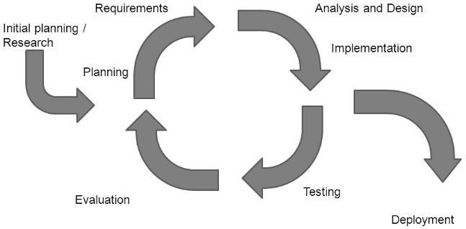

**Figure 5.2 System Model**